Cloverbud Record Book Instructions
DO NOT INCLUDE THESE INSTRUCTION PAGES WITH YOUR FINISHED RECORD BOOK

1. Please complete these pages*

2. Place them in a binder

3. Return them to your club leaders for review by the due date they set (usually in August)

*Notes:

- Your child may fill them out on the computer and then print or you may print them off and complete by hand, but the physical act of writing or drawing is especially important at this developmental stage.

- The Cloverbud may draw pictures or write words. They may narrate and someone may write the words down.

We encourage filling out record books for the following reasons:
- It teaches life skills of good record keeping.
- Encourages reflection on the year which enhances project learning.
- After 5th grade, record books are necessary to receive county awards

CLOVERBUDS
Record Book

Hi, my name is .

I am a member of the ___________________4-H Club.

This is my year in 4-H.

I am years old and in the grade.

In my free time I like to ,

I have people in my family. I hope you enjoy my record book.

Attach a picture of you, here.

The 4-H emblem is:
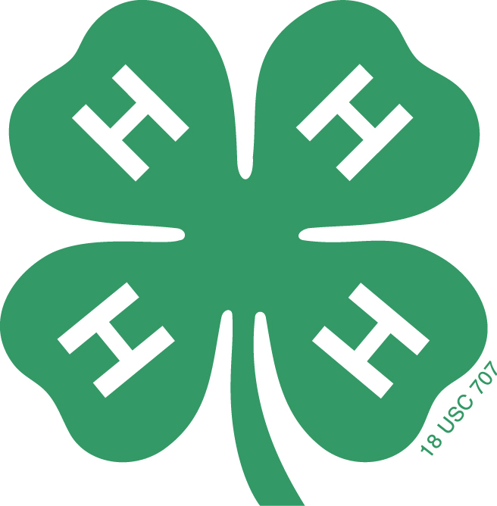
A green four-leaf clover with
The letter “H” on each leaf is
The emblem. Each “H” stands
for a part of the pledge—
Head,
Heart,
Hands,
Health

The 4-H colors are:
Green and White.
Green symbolizes nature’s most common color.
White symbolizes purity.

The 4-H motto is:
“To Make the Best Better”
This motto challenges everyone involved in 4-H to
do the very best job they can.

Flag Pledges

The American Flag Pledge:
“I pledge allegiance to the flag of the United States of America, and to the republic for which it stands, one nation under God, indivisible, with liberty and justice for all.”

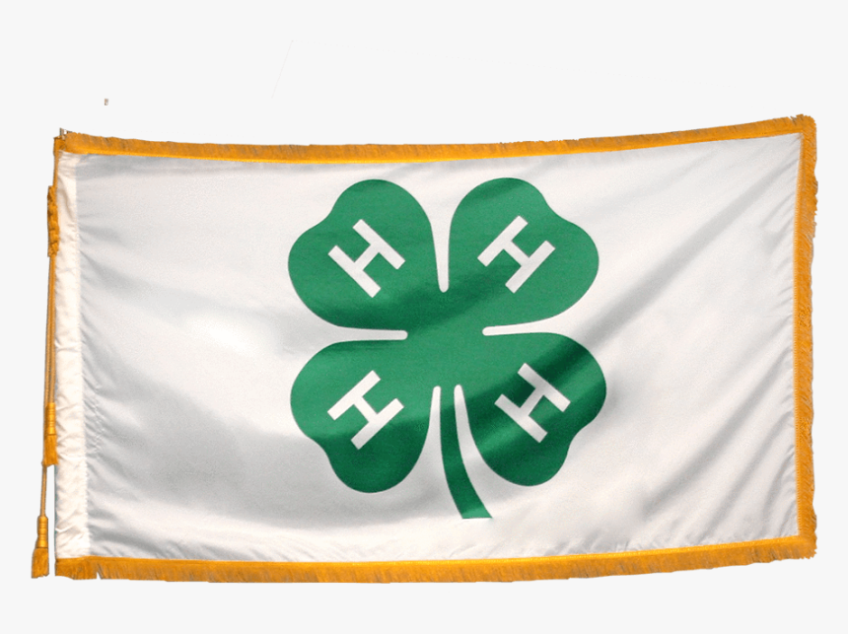(When repeating the pledge, your right hand should be placed over your heart, which is on the left side of your body.)

The National 4-H Pledge:
I Pledge:
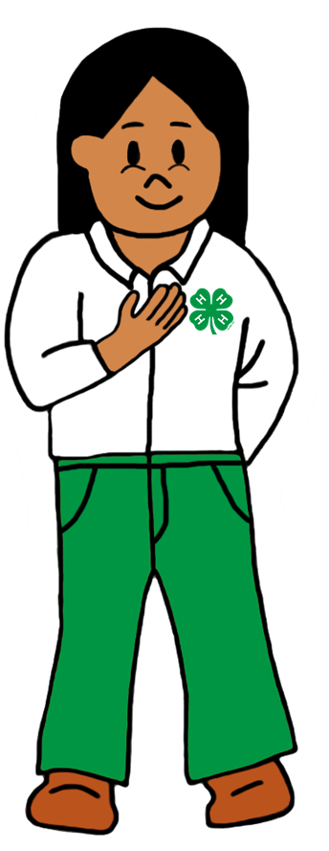
(Right hand point to forehead)
My Head to clearer thinking

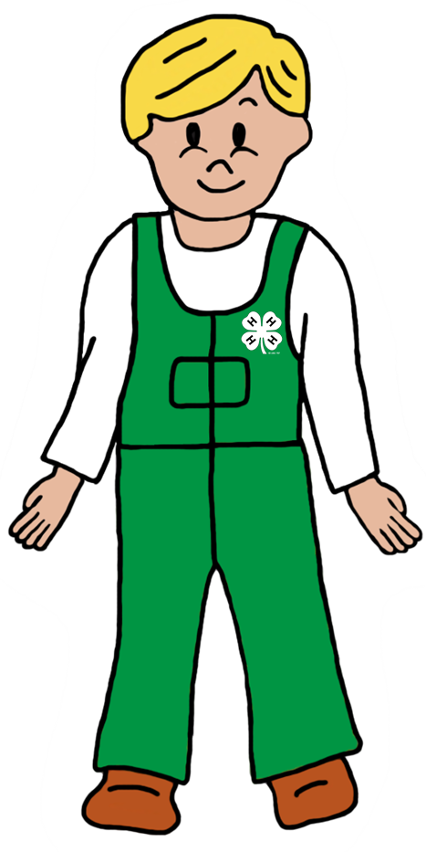 My Heart to greater loyalty

My Hands to larger service, and
(Right hand over heart)

My Heath to better living for my club,
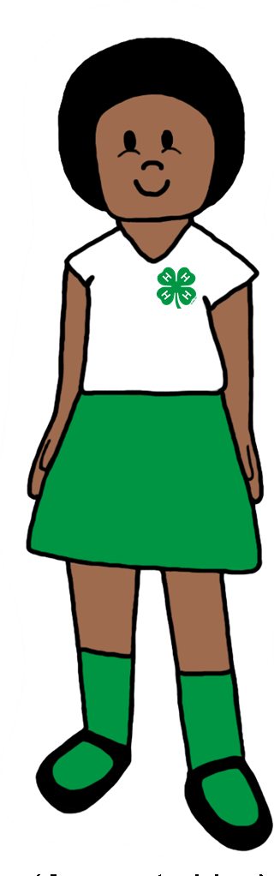 my community, my country,
(Arms slightly bent with palms up)
and my world.

(Arms at sides)

THINGS WE DID THIS YEAR
LIST CLUB ACTIVITIES AND EVENTS YOU PARTICIPATED IN THIS YEAR.

September:

October:

November:

December:

January:

February:

March:

April:

May:

June:

July:

August:

My 4-H Projects:

Clippings/Photos/Drawings
about things I made.

What I learned while doing this was:

What I like best about this item was:

Did you exhibit this at:
County Fair Yes
Club Tour or Meeting Yes
Other public event Yes

Next year I want to learn about:

Voice of the Parent/Guardian:
(This is your point of view of how your child’s 4-H year went.)

Member signature Parent signature

Updated 4/24/20

