Record Book Instructions
This format is for 3rd through 12th grade Video
One of the requirements to achieve in Eau Claire County 4-H is to create and submit a record book each year. The actual due date varies from club to club, so please check with your club’s general leader. Besides achieving, doing a record book has many benefits.
- It is necessary to be nominated for county awards.
- It is necessary when applying for 4-H Experience(s)s (trips).
- It teaches life skills of good record keeping.
- Encourages reflection on the year which enhances project learning.
PLEASE READ ALL INSTRUCTIONS BEFORE COMPLETING
Image of Page | Instructions for this page
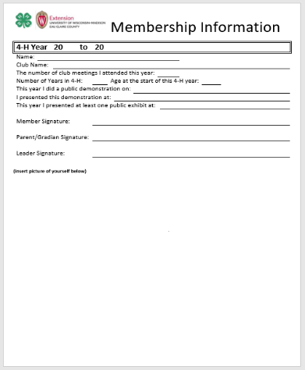 | Membership Information  This page is to document information about you and to capture signatures.  An achieving 4-H member:  - Attended at least four club meetings  - Presented a public demonstration  - Presented a public exhibit  - Submitted a completed record book  Fill in the year section with the corresponding 4-H years. Click your cursor at the beginning of each underline and begin typing.  Please print this page and collect required signatures. Then submit this page with the item/link you saved your video on.
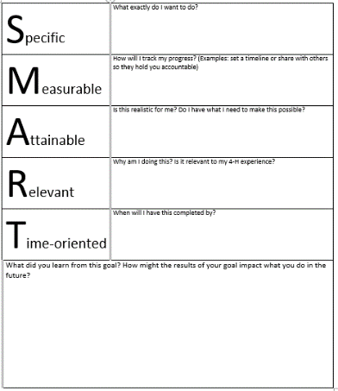 | SMART Goals  - Please set and document at least one SMART Goal. To document additional SMART Goals, please make a copy of this page.  - SMART Goal(s) should be set at the beginning of each 4-H year.  - Your SMART Goal(s) should be specific to a 4-H project and/or 4-H related.  - Once you have achieved your SMART Goal(s), complete the “What did you learn” portion of this page. (If you do not achieve your SMART Goal(s), document why)  Options:  - Print this completed page and submit with the item/link you saved your video on.  (Click your cursor below each question and begin typing).  OR  - Please make sure to answer all of these questions in your video.
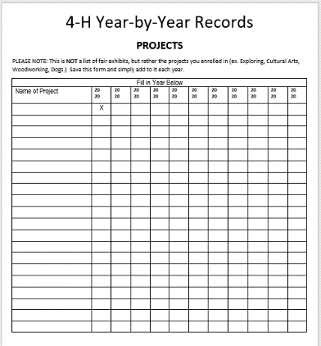 | 4-H Year by Year Records – Projects  Use this page to list all of the projects you have enrolled in on 4-Honline.  This is NOT a list of fair/public exhibits, but rather the projects you  enrolled in (ex. Exploring, Art, Woodworking, Dogs.)  Print this completed page and submit with the item/link you saved your video on.  Click your cursor in each cell below “Name of Project” and begin typing.  Fill in the years and check off each corresponding project.  Save this form and simply add to it each year.

Record Book Instructions (Continued)
Image of Page | Instructions for this page
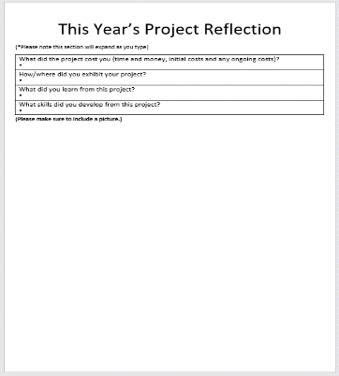 | This Year’s Project Reflection  - Please select and reflect on at least one project from this year. You are welcome to reflect on more than one.  - You will need to answer each question in your video. (keeping receipts will be helpful to complete this page)  Please make sure to include images of the project(s) you reflect on in your video.
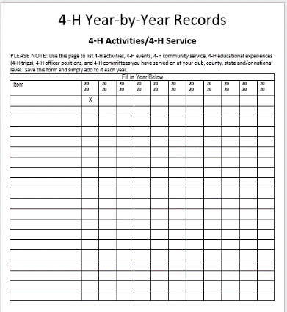 | 4-H Year by Year Records – Activities/Service  Use this page to list items you participated in at your club, county, state and national level:  - 4-H activities  - 4-H events  - 4-H community service  - 4-H Educational Experience(s)s (trips)  - 4-H officer positions you have held  - 4-H committees you have served on  Print this completed page and submit with the item/link you saved your video on.  Click your cursor in each cell below “Item” and begin typing. Fill in the years and check off each corresponding item.  Save this form and simply add to it each year.
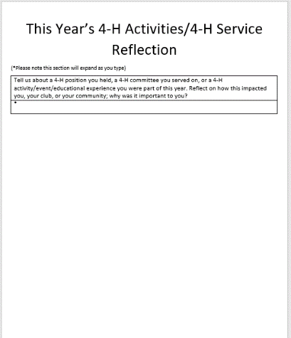 | This Year’s 4-H Activities/4-H Service Reflection  - Please select and reflect on at least one of the following. You are welcome to reflect on more than one.  - 4-H position you held this year  - 4-H committee you served on this year  - 4-H activity/event/Experience(s) you were part of this year  - You will need to answer each question in your video.
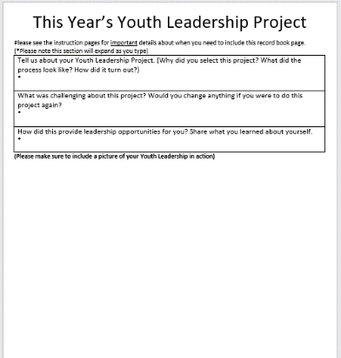 | This Year’s Youth Leadership Project  IF YOU PLAN ON REQUESTING FUNDS FOR AN EDUCATIONAL EXPERIENCE(S) (4-H TRIP) OR YOU WOULD LIKE A CHANCE TO BE NOMINATED BY A LEADER FOR A COUNTY AWARD, YOU ARE REQUIRED TO ENROLL IN THE YOUTH LEADERSHIP PROJECT AND THIS RECORD BOOK PAGE IS REQUIRED. If neither of these interest you, this record book page can be omitted.  - You will need to answer each question in your video.  Please make sure to include images of your Youth Leadership project(s) thayou reflect on in your video.
Record Book Instructions (Continued)
Image of Page | Instructions for this page
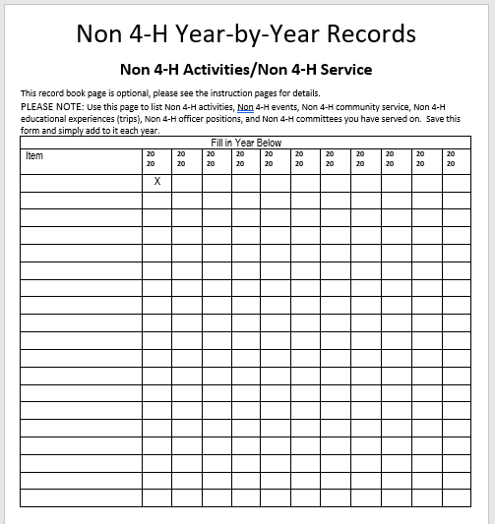 | Non 4-H Year by Year Records - Non 4-H Activities/Non 4-H Service  THIS RECORD BOOK PAGE IS OPTIONAL and can be omitted. Use this page to list Non 4-H items you participated in:  - Non 4-H activities  - Non 4-H events  - Non 4-H community service  - Non 4-H educational Experience(s)s (trips)  - Non 4-H officer positions you have held  - Non 4-H committees you have served on  Print this completed page and submit with the item/link you saved your video on.  Click your cursor in each cell below “Item” and begin typing. Fill in the years and check off each corresponding item.  Save this form and simply add to it each year.
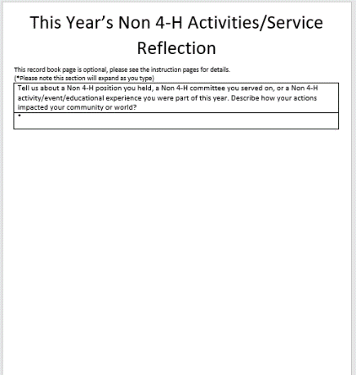 | This Year’s Non 4-H Activities/Non 4-H Service Reflection  THIS RECORD BOOK PAGE IS OPTIONAL and can be omitted.  - Please select and reflect on at least one of the following. You are welcome to reflect on more than one.  - Non 4-H position you held this year  - Non 4-H committee you served on this year  - Non 4-H activity/event/Experience(s) you were part of this year  - You will need to answer each question in your video.
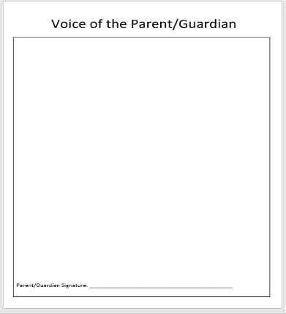 | Voice of the Parent/Guardian  This page is completed by your parent/guardian. This is their point of view of how your 4-H year went.  - Parent/guardian should click cursor in the text box and begin typing.  Print this completed page and submit with the item/link you saved your video on.  *If sharing your video on line, make sure the link is visible to anyone with the link. More information can be found here. Share a file publicly
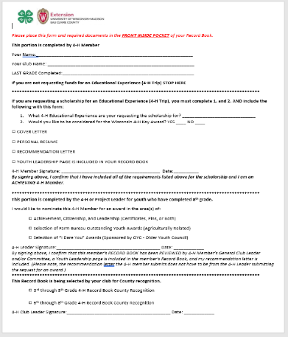 | Please submit this completed form with the item/link you saved your video on. Follow the instruction listed on this form.  Click your cursor at the beginning of each underline and begin typing.  Additional instructions for youth completing the scholarship portion and for leaders completing the award portions can be found on the Eau Claire County Extension website.  Please note: If you would like to include additional pages in your record book with more pictures and/or include ribbons and certificates you are welcome to do so. However, outside of where it is specifically indicated to include pictures, it is not a requirement to include more.
DO NOT INCLUDE THESE INSTRUCTION PAGES WITH YOUR FINISHED RECORD BOOK

 Membership Information
4-H Year |  | 20 |  | to | 20
Name:
Club Name:
The number of club meetings I attended this year:
Number of Years in 4-H: |  |  |  |  |  |  | Age at the start of this 4-H year:
This year I did a public demonstration on:
I presented this demonstration at:
This year I presented at least one public exhibit at:
Member Signature:
Parent/Guardian Signature:
Leader Signature:

(insert picture of yourself below)

S.M.A.R.T. GOAL
Specific | What exactly do I want to do?
Measurable | How will I track my progress? (Examples: set a timeline or share with others so they hold you accountable)
Attainable | Is this realistic for me? Do I have what I need to make this possible?
Relevant | Why am I doing this? Is it relevant to my 4-H Experience(s)?
Time-oriented | When will I have this completed by?
What did you learn from this goal? How might the results of your goal impact what you do in the future?

4-H Year-by-Year Records
PROJECTS
PLEASE NOTE: This is NOT a list of fair exhibits, but rather the projects you enrolled in (ex. Exploring, Art, Woodworking, Dogs, etc.) Save this form and simply add to it each year.
Fill in Year Below
Name of Project | 20  20 | 20  20 | 20  20 | 20  20 | 20  20 | 20  20 | 20  20 | 20  20 | 20  20 | 20  20 | 20  20
 | X

This Year’s Project Reflection
(*Please note this section will expand as you type)
What did the project cost you (time and money, initial costs and any ongoing costs)?
*

How/where did you exhibit your project?
*

What did you learn from this project?
*

What skills did you develop from this project?
*

(Please make sure to include a picture.)
4-H Year-by-Year Records
4-H Activities/4-H Service
PLEASE NOTE: Use this page to list 4-H activities, 4-H events, 4-H community service, 4-H educational Experience(s)s (4-H trips), 4-H officer positions, and 4-H committees you have served on at your club, county, state and/or national level. Save this form and simply add to it each year.
Fill in Year Below
Item | 20  20 | 20  20 | 20  20 | 20  20 | 20  20 | 20  20 | 20  20 | 20  20 | 20  20 | 20  20 | 20  20
 | X

This Year’s 4-H Activities/4-H Service Reflection
(*Please note this section will expand as you type)
Tell us about a 4-H position you held, a 4-H committee you served on, or a 4-H activity/event/educational Experience(s) you were part of this year. Reflect on how this impacted you, your club, or your community; why was it important to you?
*

This Year’s Youth Leadership Project
Please see the instruction pages for important details about when you need to include this record book page.
(*Please note this section will expand as you type)
Tell us about your Youth Leadership Project. (Why did you select this project? What did the process look like? How did it turn out?)
*

What was challenging about this project? Would you change anything if you were to do this project again?
*

How did this provide leadership opportunities for you? Share what you learned about yourself.
*

(Please make sure to include a picture of your Youth Leadership in action)

Non 4-H Year-by-Year Records
Non 4-H Activities/Non 4-H Service
This record book page is optional, please see the instruction pages for details.
PLEASE NOTE: Use this page to list non 4-H activities, non 4-H events, non 4-H community service, non 4-H educational Experience(s)s (trips), Non 4-H officer positions, and Non 4-H committees you have served on. Save this form and simply add to it each year.
Fill in Year Below
Item | 20  20 | 20  20 | 20  20 | 20  20 | 20  20 | 20  20 | 20  20 | 20  20 | 20  20 | 20  20 | 20  20
 | X

This Year’s Non 4-H Activities/Service Reflection
This record book page is optional, please see the instruction pages for details.
(*Please note this section will expand as you type)
Tell us about a Non 4-H position you held, a Non 4-H committee you served on, or a Non 4-H activity/event/educational Experience(s) you were part of this year. Describe how your actions impacted your community or world?
*

Voice of the Parent/Guardian
Parent/Guardian Signature: ____________________________________________________________________

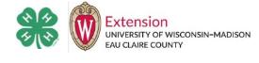
Nomination Form
Please place this form and required documents in the FRONT INSIDE POCKET of your Record Book.
This portion is completed by 4-H Member
Your Name:
Your Club Name:
LAST GRADE completed: |  |  |  | Email:

**************************************************************************************************
Would you like to be considered for the Wisconsin 4-H Key Award? Yes ___ No___
If so, include the following with this form:
☐ COVER LETTER ☐ RECOMMENDATION LETTER
☐ PERSONAL RESUME ☐ Youth Leadership page is included in your Record Book
4-H Member Signature: ____________________________________________________ Date: __________
By signing above, I confirm that I have included all the requirements listed above for the award and I am an ACHIEVING 4-H Member.
**************************************************************************************************
This portion is completed by the 4-H Club or Project Leader for youth who have completed at least 8th grade.
I would like to nominate this 4-H Member for a county level award in the area(s) of:
☐ Achievement, Citizenship, and Leadership (Certificates, Pins, or Both)
☐ Selection of Farm Bureau Outstanding Youth Awards (Agriculturally Related)
☐ Selection of “I Dare You” Awards (Sponsored by OYC - Older Youth Council)
4-H Leader Signature: ______________________________________________________ Date: ____________
By signing above, I confirm that this member’s RECORD BOOK has been REVIEWED by 4-H Member’s General Club Leader and/or Committee, a Youth Leadership page is included in the member’s Record Book, and my recommendation letter is included. (Please note, the recommendation letter the 4-H member submits does not have to be from the 4-H Leader submitting the request for a county level award.)
**************************************************************************************************
This Record Book is being selected by your club for county recognition.
◻ Cloverbud ◻ 3rd through 5th Grade
◻ 6th through 8th Grade
4-H Club Leader Signature: _________________________________________________ Date: ____________
Include page 2 if you would like to apply for a scholarship or funds.
Nomination Form, page 2
__________________________________ is requesting funds from the Leaders Association.
The scholarship and funding request portion of the Nomination form is applicable for events applied for during the current 4-H year; the Leaders Association will cover up to 1/3 of the cost of the experience/opportunity. Nominations forms can be turned in by the second Tuesday in September and by the third Tuesday in January. Nomination forms can also be turned in on an as-needed basis; funding will be determined based on funds available for that 4-H year.
Please refer to the Nomination Form Guidelines for Eau Claire County 4-H and the ECC-Chart of Teams/Experiences/Awards found on the Extension Eau Claire County Website for more information.
**************************************************************************************************
To apply for a scholarship for an Educational Experience(s) (4-H Trip), complete this section.
Education Experiences include Summer Academy @ UW-Madison, American Spirit Experience-East, CWF - Citizen Washington Focus in Washington D.C., National 4-H Congress in Atlanta, Ga., National 4-H Conference in Washington D.C., International Exchange, CWF-Presidential Inauguration, and Space Camp Counselor.
What 4-H Educational Experience are your requesting the scholarship for?
Include the following with this form:
◻ COVER LETTER ◻ RECOMMENDATION LETTER
◻ PERSONAL RESUME ◻ Youth Leadership page is included in your Record Book
4-H Member Signature: ____________________________________________________ Date: __________
By signing above, I confirm that I have included all the requirements listed above for the scholarship and I am an ACHIEVING 4-H Member. My prior year’s record book with above documents will be turned into the Extension Office by the second Tuesday in September and/or the third Tuesday in January.
**************************************************************************************************
To request funding for an Educational Opportunity(s), complete this section.
Education Opportunities include, but are not limited to, State Art Groups (4-H Drama Company, 4-H Art Team, 4-H Communications Team), Space Camp, Fall Forum, Art Camp, and ArtBeat.
What 4-H Educational Opportunity are you requesting funding for?
Include the following with this form:
◻ COVER LETTER (include the name and total cost of educational opportunity, a youth leadership experience you led/facilitated during the past 4-H year, and 4-H involvement)
4-H Member Signature: ____________________________________________________ Date: __________
By signing above, I confirm that I have included all the requirements listed above for the funding request and I am an ACHIEVING 4-H Member. The nomination form and cover letter will be turned into the Extension Educator at the Extension Office or via email to Rachel.hartbrinson@wisc.edu by the second Tuesday in September and/or the third Tuesday in January.

**************************************************************************************************
Rev 8/2024

